A000-Asia-Indus-Harappa-Bajaur Valley-Priestess with wig emplacement-Terra cotta-2500 BCE

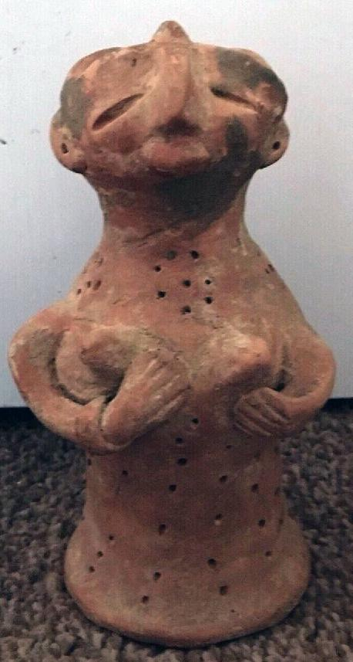 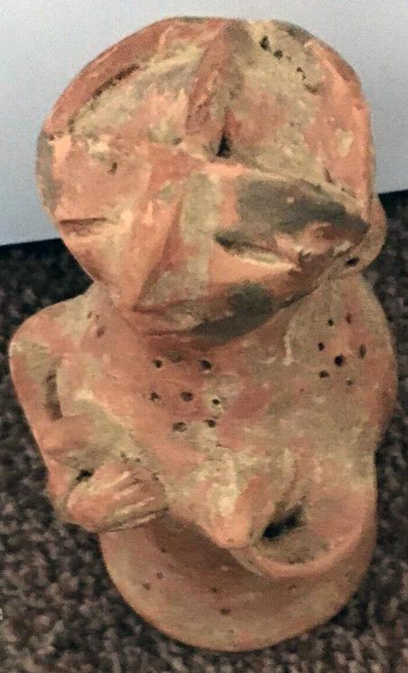 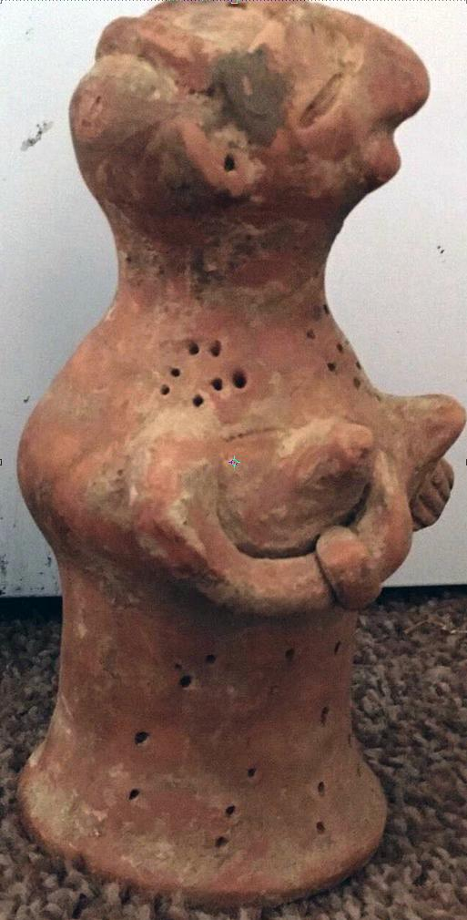

Case no.: 3

Accession Number:

Formal Label:

**Display Description:**

**LC Classification:**

Date or Time Horizon:

Geographical Area:

**Map:**

**GPS coordinates:**

Cultural Affiliation:

Media:

Dimensions:

Weight:

Condition:

Provenance:

**Discussion:**

**References:**

Very rare Indus Valley mother goddess with lots 2000bc

Size 20cm X 9cm part of an old collection

Complete no cracks

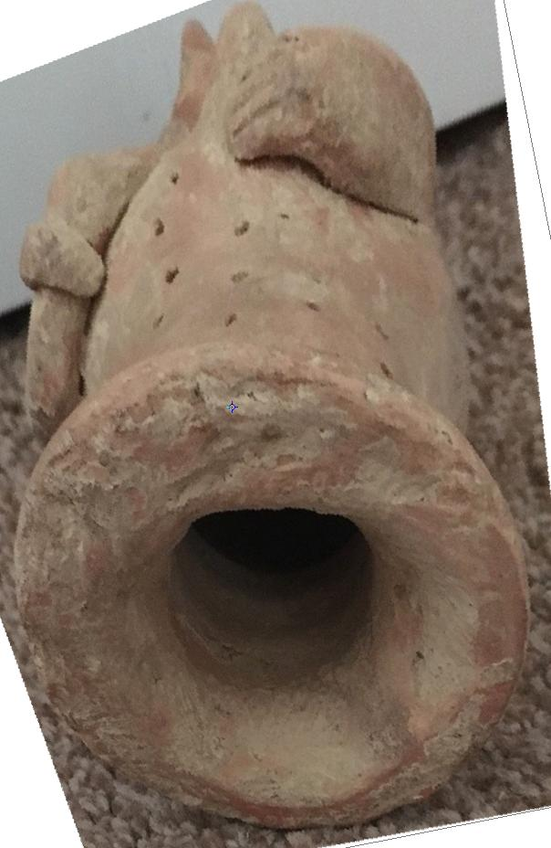 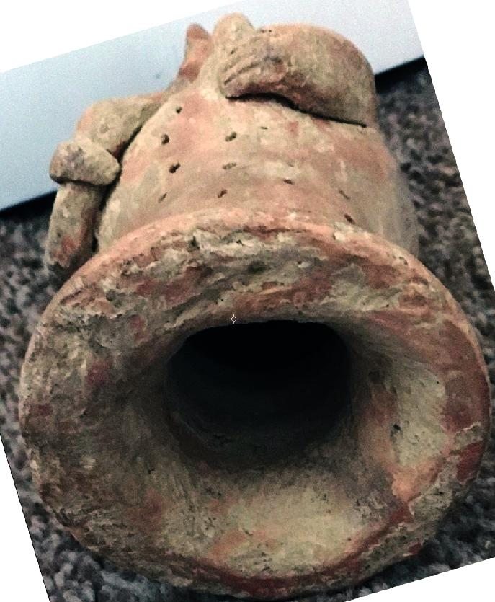

## This hollow bell-shaped terracotta figurine is probably from Bajaur valley (area of 600 sq. miles), a hilly area located northwest of Malakand at the border between Pakistan and India, in the sphere of influence of the early Harappan Civilization during the so called Regionalization Era, 2800-2600 BCE (Kenoyer 1998: 39-45).

This figurine’s head is oriented horizontally, her eyes are open and piercing, her mouth is open as if speaking to an audience, suggesting a cinematographic moment caught in time to which we are invited. The figurine has applied terracotta arms, nose, lips, necklace and hairstyle. A pinched beak-like nose is suggestively avian, recalling many Neolithic female cultic figures with bird-like features possibly indicative of their worship of an avian heavenly deity. It is well known that among the cultures extending from the Tibetan Plateau to western India and Pakistan through Afghanistan to Turkey, the practice of excarnation or allowing carrion birds such as vultures to ingest the bodies of the deceased and so imbibe their spirit wasextensively practiced. In this context the curve of the votive cultic offrand suggests that the deity involved was associated with the local carrion birds, which in the case of Harappa would have been the gyphon vulture. The bell-shaped hollow body is illustrative of the flowing skirts of Bajaur Valley female cultic figurines. This one is impressed with several diagonal lines of dots below the chest possibly suggesting folds in a skirt. Dots in a necklace suggest precious stones or pearls and may indicate elevated social status. Lack of prominent breasts suggest that this figurine portrays an older female priestess of the goddess Asherah or her cognate in the Harappa civilization engaged in assisting cultic worshippers in successful childbearing who are themselves nubile. The hairdressing with a semi-circular gathering and surmounted with a promininent bob also suggests a stylized priestly accoutrement. The left lower arm and ears are missing.

2016; Barakat Gallery, 405 North Rodeo Drive, Beverly Hills, California-90210); Pd 400 USD Australian Collection, 2016). Extremely rare.

REFERENCES

**Kenoyer, Jonathan Mark. 1998. *Ancient cities of the Indus Valley Civilization.* Karachi, Pakistan: American Institute of Pakistan Studies, Oxford University Press.**

Beautiful  large and very rare **Ancient Indus Valley Terracotta MOTHER  GODDESS**,  17.5 cm height, 9.5 cm diameter at base In an excavated condition. Has had a red-brown paint over the majority of its surface, only remnants left. Ex-U.K. collection. From the earlier end of the ancient Indus Valley civilization around 2300**B.C**.E. Indus Valley was only discovered for the west in 1921 and excavations didn't begin till 1926 and never on the scale of Ancient Egypt even though they existed at the same point in time, only a few thousand km's apart. Indus have been found to have been the earliest users of polychrome paints, surpassing the Mesopotamians who were thought to be the earliest, they have now been found to be the earliest practitioners of dentistry, were advanced in town planning, sewerage and water.  Certificate Of Authenticity supplied.

# Order details

Printer friendly page

## Sales order

Sold by [dave1000.123](http://myworld.ebay.com/dave1000.123) ( [3402](http://feedback.ebay.com/ws/eBayISAPI.dll?ViewFeedback&userid=dave1000.123) )

+ Show additional actions

### Delivery package 1 of 1

Estimated delivery Friday, May 20, 2016 -Wednesday, Jun 1, 2016

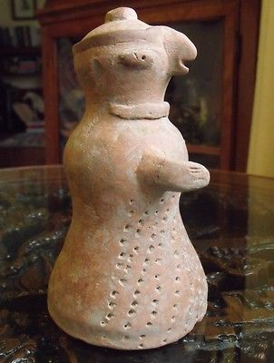

#### [RARE ANCIENT INDUS VALLEY MOTHER GODDESS ca.2300 BC. Harappan Culture](http://www.ebay.com/itm/311506251137)